**Assignment -2**

Python Programming

|  |  |
| --- | --- |
| Assignment Date | 19 September 2022 |
| Student Name | Magar Pranathi |
| Maximum Marks | 2 Marks |

**Question-1:**

Download the dataset: Dataset

**Solution:**

https://drive.google.com/file/d/1_HcM0K8wt4b7FMLkc1V1dv0y6I_9ULzy/view

**Question-2:**

Load the dataset. **Solution:**

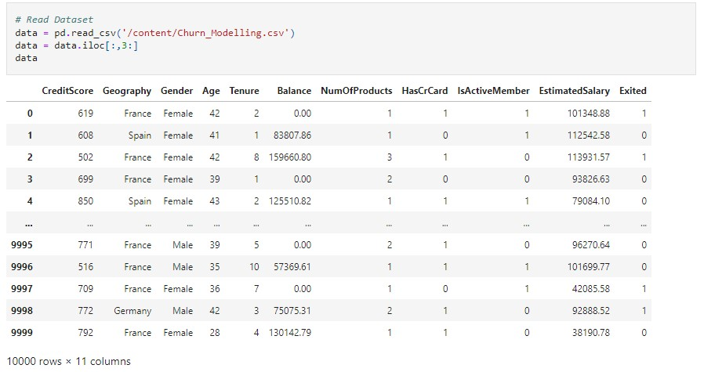

**Question-3:**

Perform Below Visualizations.

* Univariate Analysis
* Bi - Variate Analysis
* Multi - Variate Analysis

**Solution:**

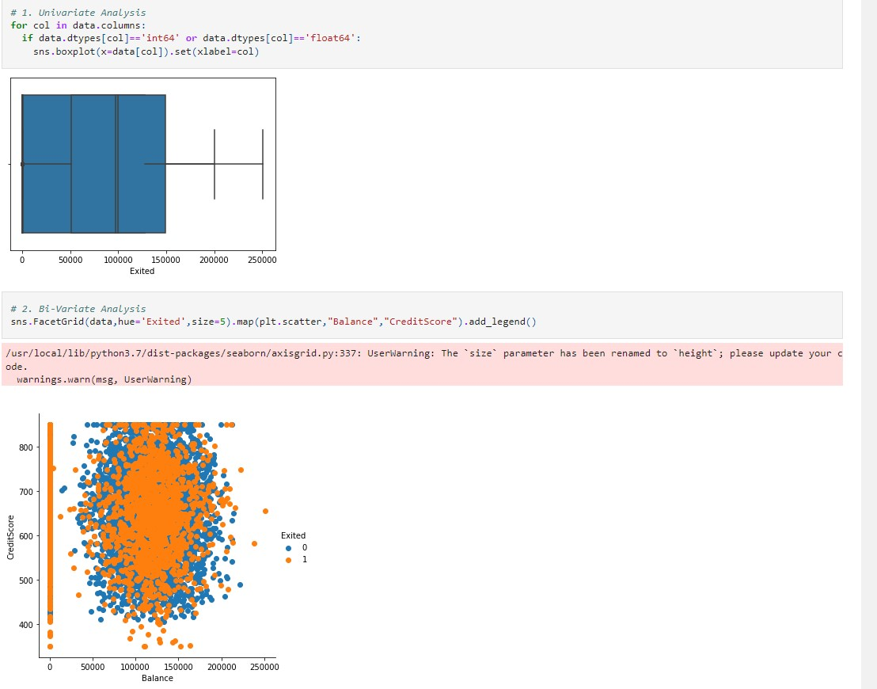

**Question-4:**

**Perform descriptive statistics on the dataset.**

**Solution:**

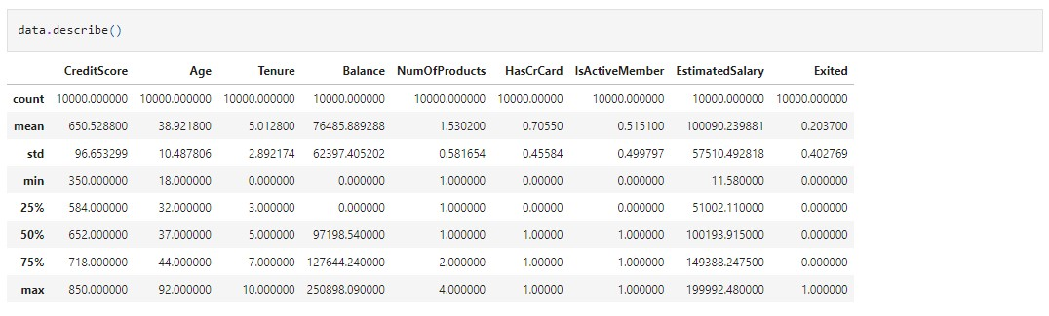

**Question-5:**

**Handle the Missing values. Solution:**

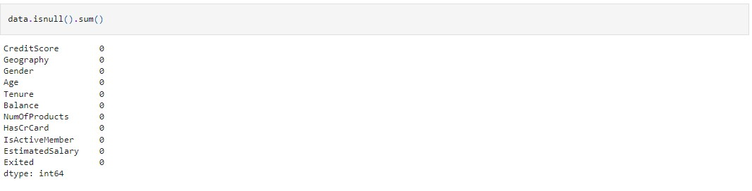

**Question-6:**

**Find the outliers and replace the outliers Solution:**

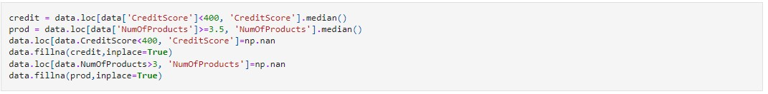

**Question-7:**

**Check for Categorical columns and perform encoding. Solution:**



**Question-8:**

**Split the data into dependent and independent variables. Solution:**



**Question-9:**

**Scale the independent variables Solution:**



**Question-10:**

**Split the data into training and testing Solution:**

